Financial Lit Name: _______________________

______________ _____________

WS Assessment

Target 4:

Supply and demand

**I can:**

* Understand the slopes of the supply and demand curves
* Find the points of equilibrium

**Unit 2 Math Topics:**

* Causal relationship
* Functions - domain and range
* Linear equation – slope-intercept form
* Linear regression
* Parabola – vertex and axis of symmetry
* Quadratic formula
* Scatterplots and correlation
* Spreadsheets and formulas
* Transitive property of dependence

Any set of numbers is called a set of **data**. Data that lists pairs of numbers and shows a relationship between the paired numbers is called **bivariate** data. If a business owner keeps records of the number

of units sold each month and the monthly sales amount, the set is bivariate data.

A **scatterplot** is a graph that shows bivariate data using points on a graph. Scatterplots may show a general pattern, or trend, within the data. A trend may show a **correlation**, or association, between two variables. A trend may also show a **causal relationship**, which means one variable caused a change in the other variable.

Rachael runs a concession stand at the park, where she sells water bottles. She keeps a list of each day’s high temperature and the number of water bottles she sells each day. Rachael is looking for trends that

relate the daily high temperature to the number of water bottles she sells each day. She thinks these two variables might be related and wants to investigate possible trends using a scatterplot.

Reproduce her scatter plot in both desmos and google sheets. Check your scale.

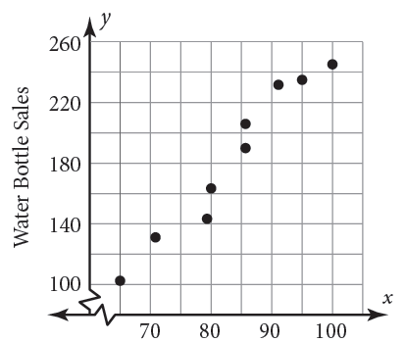

Explain the causal relationship for this set of data

_________________________________________________________________________________

Examine each scatterplot. Identify each as showing a positive correlation, a negative correlation, or no correlation.

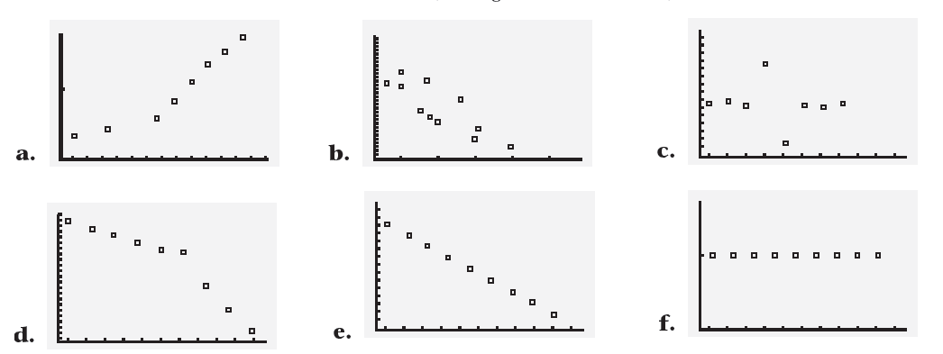

Many scatterplot points can be approximated by a single line that best fits the scattered points. This line may be called a: **line of best fit**, **linear regression line**, or **least squares line**.

Back to the data from Rachael water bottle, write the equation of linear regression line and state the correlation (both ways). Stamps

Desmos Google sheet

Rachael is stocking her concession stand for a day in which the temperature is expected to reach 106 degrees Fahrenheit. How many water bottles should she pack?

Sketc, write the equation of the linear regression line of the scatterplot defined by these points:

(1, 56), (2, 45), (4, 20), (3, 30), and (5, 9) then state its correlation (your choice of method). Stamp



A **demand** function relates the quantity of a product to its price. As the price increases, demand (the quantity

consumers want) is likely to decrease, and as price decreases, demand increases. The graph of the demand function has a negative slope. However, its curvature varies.

Producers provide supply (the quantity of items available to be sold). As price increases, supply

increases. The graph of the supply function has a positive slope. Its curvature also varies.

Economic decisions require research, and knowledge of the laws of supply and demand. To examine the law of supply and demand, graph both functions on the same axes.

Compare the supply and demand for the following situations



|  |  |  |
| --- | --- | --- |
| Price at $3.00 = shortage | Price at $7 = high inventory | Price at $6 = Equilibrium |
|  |  |  |



The graph on left shows the supply and demand curves for a widget (new product). Explain what happens if the price is set at $9.00

At $15.00?

The supply and demand curves for a new widget are shown in the graph. Notice there are two demand curves. The original demand curve is d1. Months after the product was introduced, there was a possible health concern over use of the product, and demand dropped to the new demand curve, d2. The movement of the demand curve is called a **shift**.

a. What was the equilibrium price before the demand shift?

b. What was the equilibrium quantity before the demand shift?

c. What was the equilibrium price after the demand shift?

d. What was the equilibrium quantity after the demand shift?

e. Express algebraically the difference in quantity demanded at price b before and after the shift.

f. Where would the demand curve have shifted if a health benefit of the new widget was reported? Sketch and name it d3.

**Assessment Target 4**

**I can…** do scatter plot and find line of best fit of supply and demand curve

A company that produces widgets has found its demand function to be

Q = - 1,500P + 90,000

a. For each dollar increase in the wholesale price, how many fewer widgets are demanded?

b. How many widgets would be demanded at a price of $20?

c. How many widgets would be demanded at a price of $21?

d. What is the difference in quantity demanded caused by the $1 increase in wholesale price?

e. The company sets a price of $22.50. How many widgets will be demanded?

f. How much will all of the widgets cost the store to purchase at a price of $22.50?

g. If the store marks up the widgets that cost $22.50 at a rate of 50%, what is the retail price of each widget?

Debbie is president of a company that produces garbage cans. The company has developed a new type of garbage can that is animal proof, and Debbie wants to use the demand function to help set a price. She surveys ten retailers to get an approximation of how many garbage cans would be demanded at each price, and creates a table.

a. Find the equation of the linear regression line. Round the slope and y-intercept to the nearest hundredth.

b. State the slope of the regression line and interpret the slope as a rate.

c. Find the correlation coefficient r and interpret it.

d. Based on the linear regression line, how many garbage cans would be demanded at a wholesale price of $18.00?

e. Was your answer to part d an example of extrapolation or interpolation? Explain.

f. Look at your answer to part d. If the company sold that many garbage cans at $18.00, how much money would the company receive from the garbage can sales?

Show scatterplot and equation of linear regression for stamp (your choice of desmos or google sheet)